Curriculum Vitae

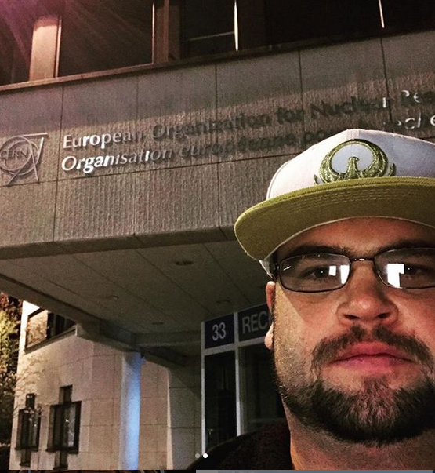

Christiaan Gerhardus Viljoen
Data Scientist

$${MSc Data Science (University of Cape Town)}^{†}$$
BSc (Med) (Hons) Bioinformatics (University of Cape Town)
BSc Human Physiology (University of Pretoria)

$†$ Thesis submission due: 31 October 2019

About Me
A true scientist at heart with an unquenchable thirst for knowledge and a hunger to solve complex problems with statistical rigor and unique creative flair.
Having a deep theoretical understanding of Deep Learning and its practical implementation with Keras; an uncanny ability to design Tableau visualizations that pop, but don’t forget to lay the core message bare; and a love for high-throughput solution-building and its subsequent communication and implementation, I make up for just 2 years of work experience with an immensely diverse educational background and extreme passion for, and dedication to, the field of Data Science.
- R
Data Wrangling
dplyR, stringR, lubRidate, etc.
Visualization & Proof of Concept Web Apps
ggplot2, shiny
Deep Learning
Keras: Vanilla Feedforward-, Convolutional- and LSTM- Neural Networks
Other Machine Learning Algorithms
h20.ai (XGBoost, Random Forests, Support Vector Machines)
API deployment
plumbeR
- Python
Keras (and a little bit of native Tensorflow): Latent Variable Models (Variational Autoencoders, Generative Adversarial Networks, Adversarial Autoencoders)
Numpy (will start upskilling in Pandas soon)
Matplotlib
- Tableau
Highly skilled as a visualization expert, Tableau Server Administration
- SQL

Work Experience

22seven Digital Pty. Ltd. (Senior Data Scientist, 2019)

At 22seven.com, my first project involved migrating management insight dashboards over from Metabase to an in-house Tableau Server, whose permissions, projects and best practices I currently manage.
Secondly, I have driven the adoption of Machine Learning into live production for the first time in 22seven’s history. A variety of potential solutions were investigated and built in order to find a transaction categorization-engine extension which is fast and accurate enough to be practically feasible.
As a Data Science team of 3 members, we spend a lot of our time developing RMarkdown reports, KPI dashboards in Tableau, as well as developing logic for “Nudges” which serve personalized financial insights to the end user.
Currently, I am researching and developing a comprehensive and reliable personal financial health score, which should open up various B2B opportunities.

BCX Insights (Specialist: Data Scientist, 2018)
BCX Insights was the ideal playground for a young Data Scientist to explore the depth and breadth of what’s possible in Data Science. Our main goals (as a Data Science start-up within the parent company of BCX) centered around B2B consulting and solution-building, across a wide range of verticals.

Summary of Projects Involved In:

BCX Agritech IoT
I was the sole data scientist on a project which focused on building an Internet-of-Things solution for the Agricultural industry. Making use of physical sensors that were installed on 3 different farms in South Africa, I built a crop-maturity forecasting solution based on expected heat unit accumulation requirements for specific crop-types and did research into developing farmer score-cards in collaboration with Solidaridad to enable small farmers to more easily qualify for loans and allow them to sell their produce more widely.

BCX IoT: Buckman Chemicals
I was the sole data scientist on a project which focused on building a paper-quality forecasting and intervention solution for Buckman Chemicals. Based on multiple variables measured during the paper production process at mills; a Cobb-level prediction solution was built in consultation with industry experts, served on a front-end which visualizes the variables involved and the predicted Cobb-level; as well as a “helper bot” which recommends chemical- and process- interventions at various stages of the production process.

BCX Echo
In collaboration with UCS’ Dolfin POS team, I was involved in building management dashboards in Tableau for various companies in the retail sector. Our solution integrated directly with the POS databases and was wrapped in a Web UI. Dashboards provided insights into various aspects of Sales and Distribution. Data sources with similar fields across companies allowed plug-and-play functionality for Massbuild, AMIC and Footgear by simply replacing data-sources on a set of default dashboards. Dashboards were then customized based on company look-and-feel and additional functionality required for each specific company was developed.

Educational Background

MSc Data Science (University of Cape Town, 2017-2019)

Thesis
“Deep Generative Modelling for High Energy Physics Event Simulations and Convolutional Neural Networks for Particle Identification”
In affiliation with CERN (The European Organization for Nuclear Research).
Participated in the 3rd Interexperimental Machine Learning Workshop at CERN (15-18 April 2019)
Possible publication in the pipeline (watch this space)
Thesis repository: https://github.com/PsycheShaman/MSc-thesis

Coursework
Statistical and High Performance Computing
Multidimensional Data Visualization
Databases for Data Scientists
Supervised Learning
Unsupervised Learning
Data Science for Industry
Data Science for Particle Physics

BSc (Med) (Hons) Bioinformatics (University of Cape Town, 2014)

Thesis
“Feature Extraction from a 3D Image Stack”

Coursework
Intensive 6-week Laboratory Techniques Course
Python Programming
Introduction to Bioinformatics
Bioinformatics for High-throughput Biology
Neurodegeneration and -regeneration

BSc Human Physiology (University of Pretoria, 2010-2012)
Human Physiology, Psychology, Genetics, Biochemistry

Others

BSocSci (UCT, 2009) *
Sociology, Religious Studies, Psychology, Biology

Bachelor of Fine Arts in Motion Picture Media (AFDA, 2008) *
Scriptwriting, Editing, Directing, Cinematography

* Passed first year, but did not pursue full degree

References

22seven
Stefan Griessel (https://www.linkedin.com/in/stefan-griesel-36aa2132/)

BCX Insights
Karin Kruger (https://www.linkedin.com/in/karinkruger/)
Stefan Steffen (https://www.linkedin.com/in/stefansteffen/)
Conrad Louw (https://www.linkedin.com/in/conrad-louw-8a287289/)

BCX IoT
Morne de Villiers (https://www.linkedin.com/in/morne-de-villiers-0bb36947/)

Academic Referees
Dr Thomas Dietel (Tom.Dietel@cern.ch)
Associate Professor Dr Darren Martin (darrenpatrickmartin@gmail.com)
Associate Professor Dr Dirk Lang (dirk.lang@uct.ac.za)

